**Part 1: Log In & Sign Up pages**

1.1 Main page (“Login” page):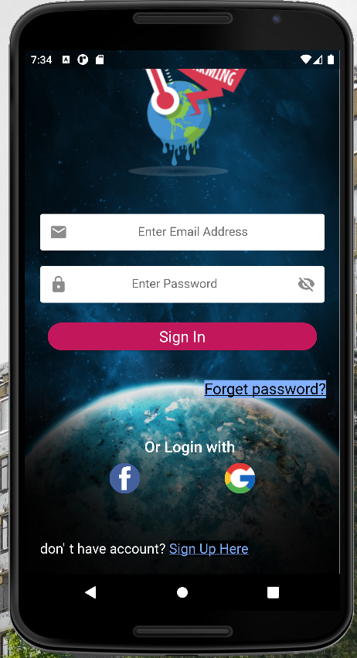

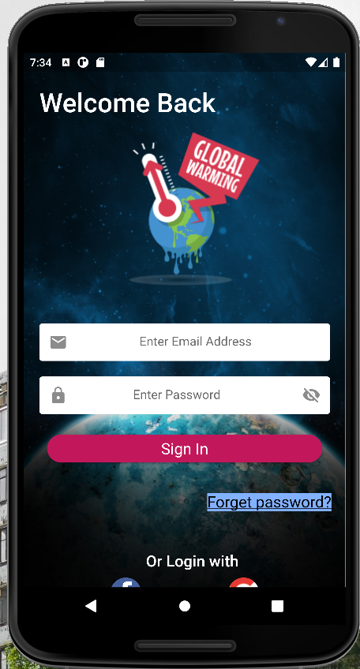

Changes to be made:

1. Replace “Forget password?” to “Forgot password?”
2. Replace “don’ t have account?” to “First time user?”

UI Functionality**:**

Scrolling functionality works well

1.2 Sign up page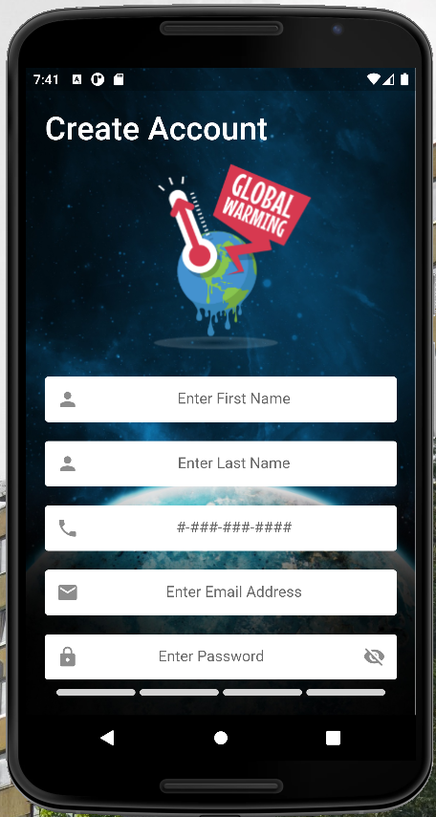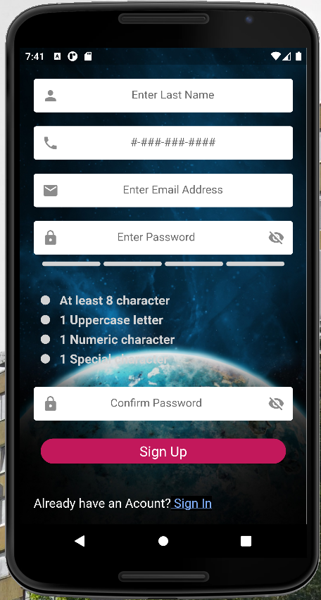

Issues**:**

1. When entering a password with a special character (such as an exclamation mark !), the suggestion hint “1 Special character” doesn’t automatically become green. Only when you click on the “eye” icon to uncover the password, does the suggestion hint become green.
2. Change “Already have an Acount?” to “Already have an account?”

**Part 2: Main App tabs**

2.1 Home/Community tab

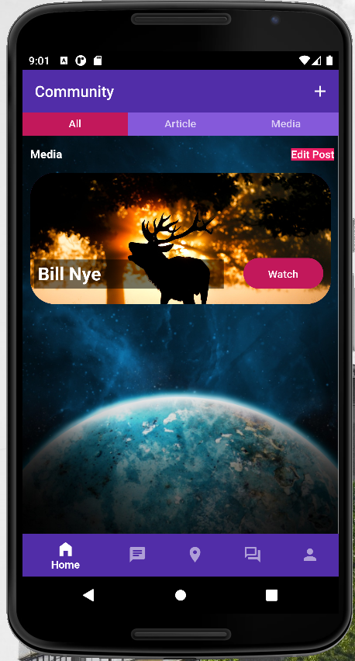

Layout and design is good and responsive. To navigate to the other subtabs “Article” and “Media” you can swipe left or right, or click on the names at the top to navigate there.

2.1.1 Adding a post to the home/community tab

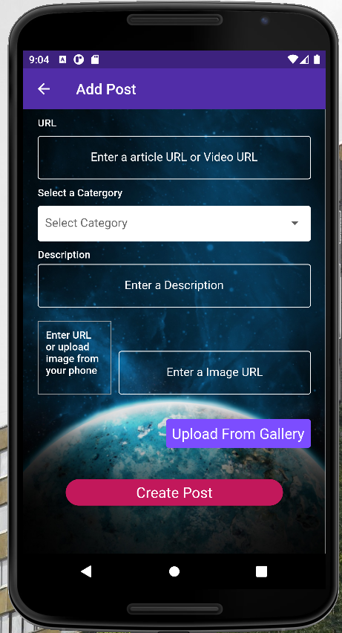

Changes to make:

1. Change “Select a Catergory” to “Select a Category”
2. When an image is uploaded from the gallery, it won’t let you create a post until you add a valid image URL.

After creating a post, your post will show up under the “All” subtab.

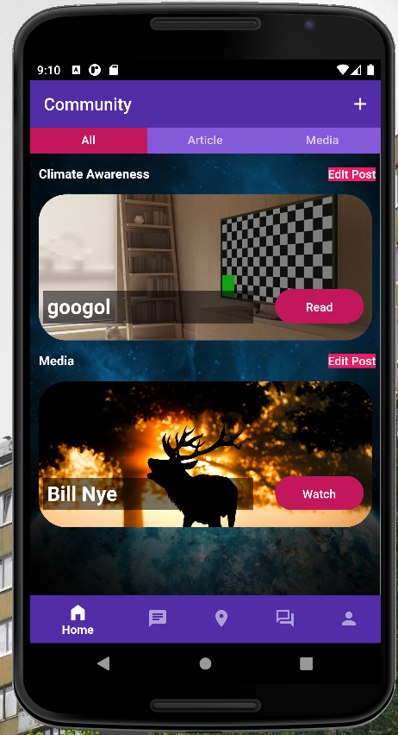

2.2 Chat tab

Under construction

2.3 Location tab

Under construction

2.4 Forum tab

This is where you will see the likes and comments from the posts on the home tab. Since we have two posts, there are two forum posts on this tab.

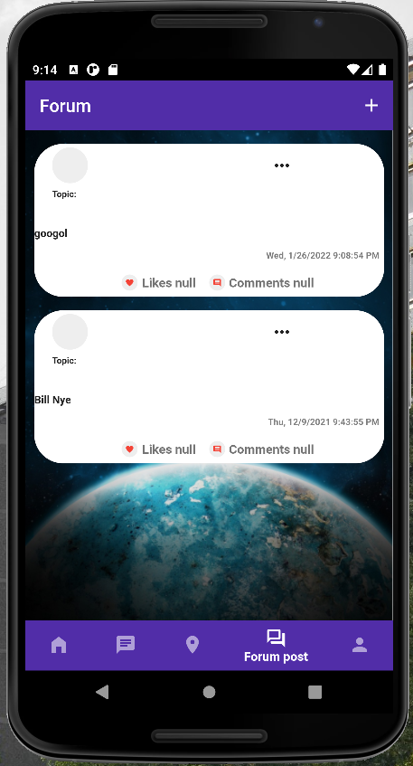

Changes to make:

1. The like and comment signifiers don’t correspond to the actual number of likes and comments, but rather just say “Null”.

If we click on a forum post, we can see that there is one like and one comment here.

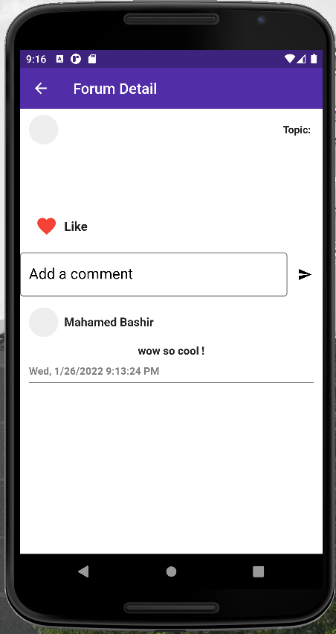

2.5 Profile tab

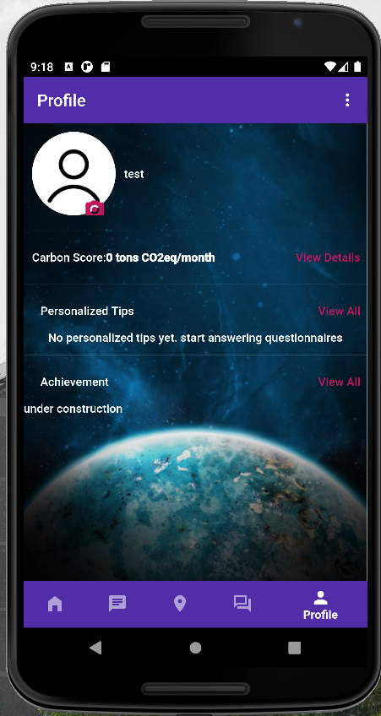

Changes to make:

1. Clicking the little camera icon next to the profile picture brings up two options, Camera and Gallery, neither of which can be clicked on.

**Part 3: Questionnaire**

To access the questionnaire, click on the triple dots in the upper right corner of the Profile tab. From here, scroll down and click on “Questionnaire”.

3.1 Quick Estimate

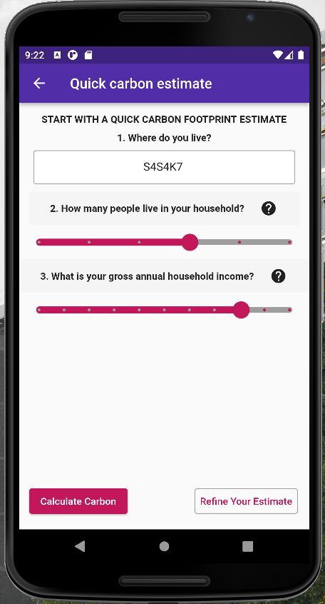

For a quick estimate, enter your postal code, and use the sliding scale to select the number of people in your household, as well as your gross annual household income, and then click “Calculate Carbon”.

Changes to make:

1. Change “Calculate Carbon” to “Calculate Carbon Footprint”

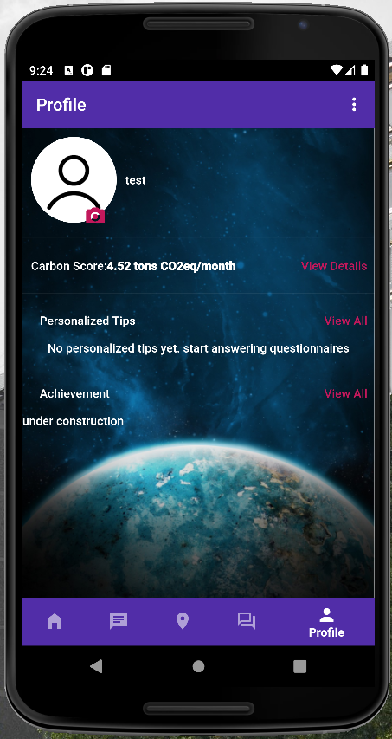

You will now be taken back to the Profile tab and you will see your Carbon Footprint score underneath your profile picture.

3.2 Detailed Estimate

To perform a detailed estimate of your Carbon Footprint, click on the “Refine your Estimate” button in the lower right corner on the Questionnaire page.

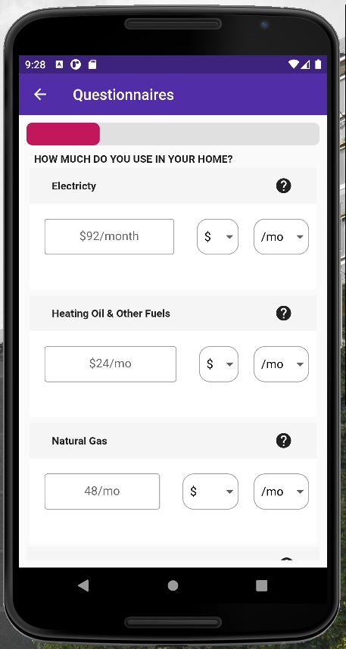

Here you will have a chance to input your usage information and get a more detailed Carbon Footprint Score

Changes to make:

1. Change “Electricty” to “Electricity”
2. Change “Advance” to “Advanced”
3. Change “Air Travelling” to “Air Travel”

3.1 Personalized Tips

After performing a detailed estimate, you will be presented with some helpful tips on the Profile tab.

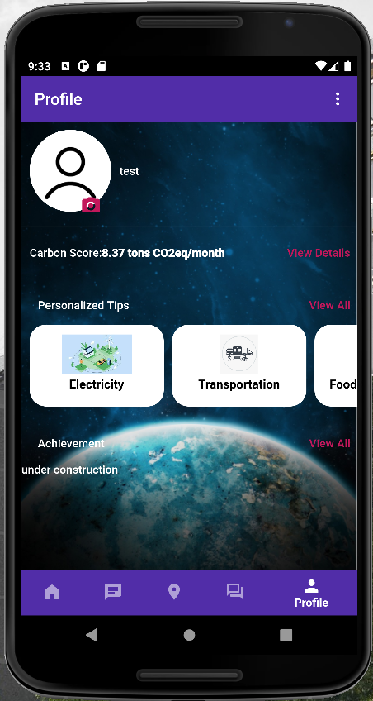

By clicking on a tip, you will be presented with some helpful information. To learn more, you can click the blue link at the bottom which will open up an article in your web browser, where you can learn more.

